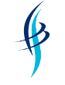

The Joseph Whitaker School
An Academy specialising in Sport and Performing Arts

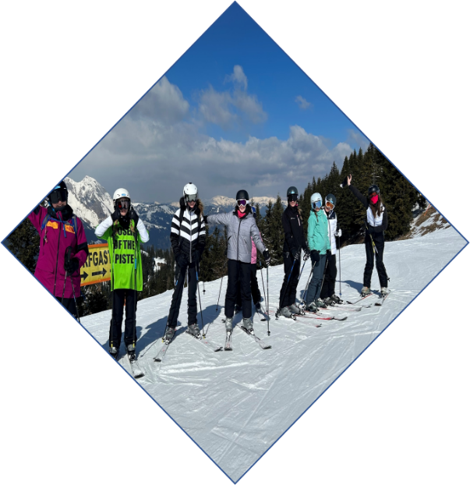
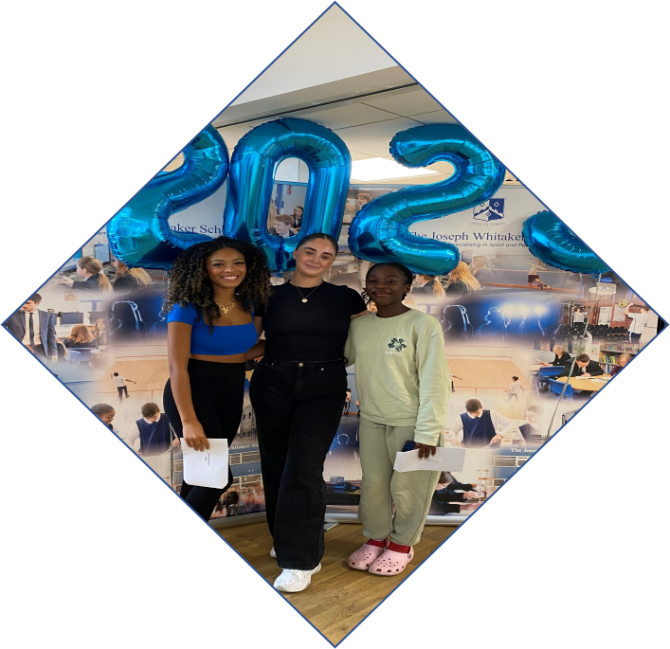
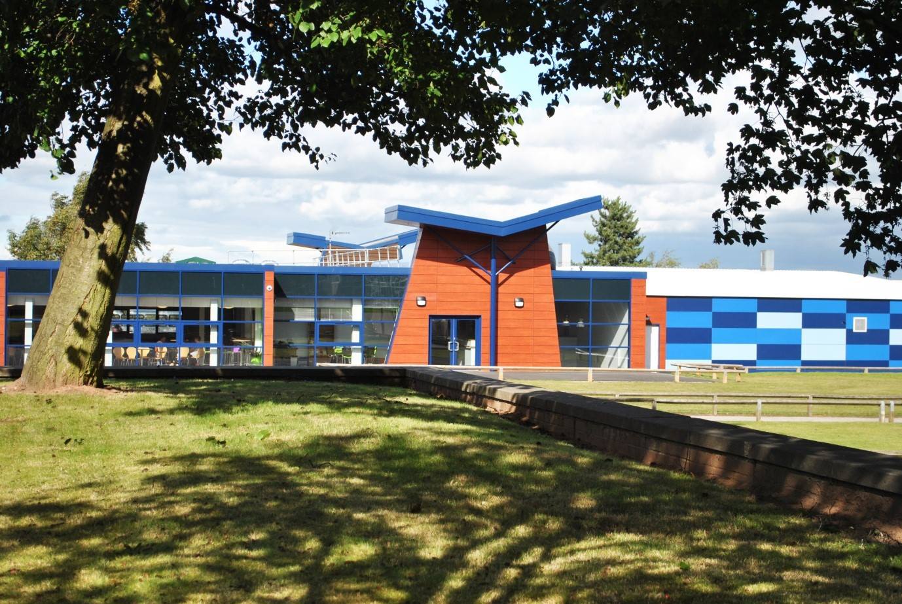
Proud to be Me. Proud to be Us.
Be Ready Be Kind Be Safe
Sixth Form Prospectus
2027 - 2028

Contents

Welcome from the Headteacher

Course Information

Additional Information

Who to Contact

Enrichment

A Level Art

A Level Biology

A Level Chemistry

A Level Computer Science

A Level Drama

A Level English Language

A Level English Literature

A Level French

A Level Geography

A Level History

A Level Mathematics

A Level Media Studies

A Level Music*

A Level PE

A Level Physics

A Level Politics

A Level Psychology

A Level Religious Studies

A Level Sociology

A Level Spanish

BTEC National Extended Certificate in Music Performance*

BTEC National Extended Certificate in Sport

Cambridge Technical Extended Certificate in Business

Cambridge Extended Certificate in Health and Social Care

Cambridge Advanced National in Human Biology

Level 3 Applied Diploma in Criminology

Extended Project Qualification

Welcome
From the Headteacher

Dear Parent/Carer

In joining The Joseph Whitaker Sixth Form you will become part of an exciting, friendly and happy learning community, full of intelligent and articulate young adults. We are very proud of our curriculum offer and examination outcomes that are a result of the continuous hard work of our highly qualified and committed staffing body.

Post-16 study is a time of opportunities and experiences and we provide excellent support to help you successfully complete your formal education before moving on to University, further education or work. We also offer the full Duke of Edinburgh Award, an enrichment programme and free access to the onsite gym.

Whilst the Sixth Form does have its own facilities including a media suite, café, social and study areas the students are an integral part of the wider school community. It is expected that all students in the Sixth Form provide good role models for the students in the main school in terms of their conduct.

Should you require any additional information please contact Mr Jacques (Head of Sixth Form) or Mr Croft (Deputy Headteacher).

The next two years should be some of the best years of your life and we hope that you choose to make The Joseph Whitaker Sixth Form part of your educational journey.

We look forward to welcoming you in the Sixth Form.

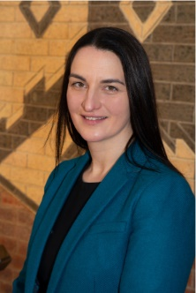
Warmest regards,
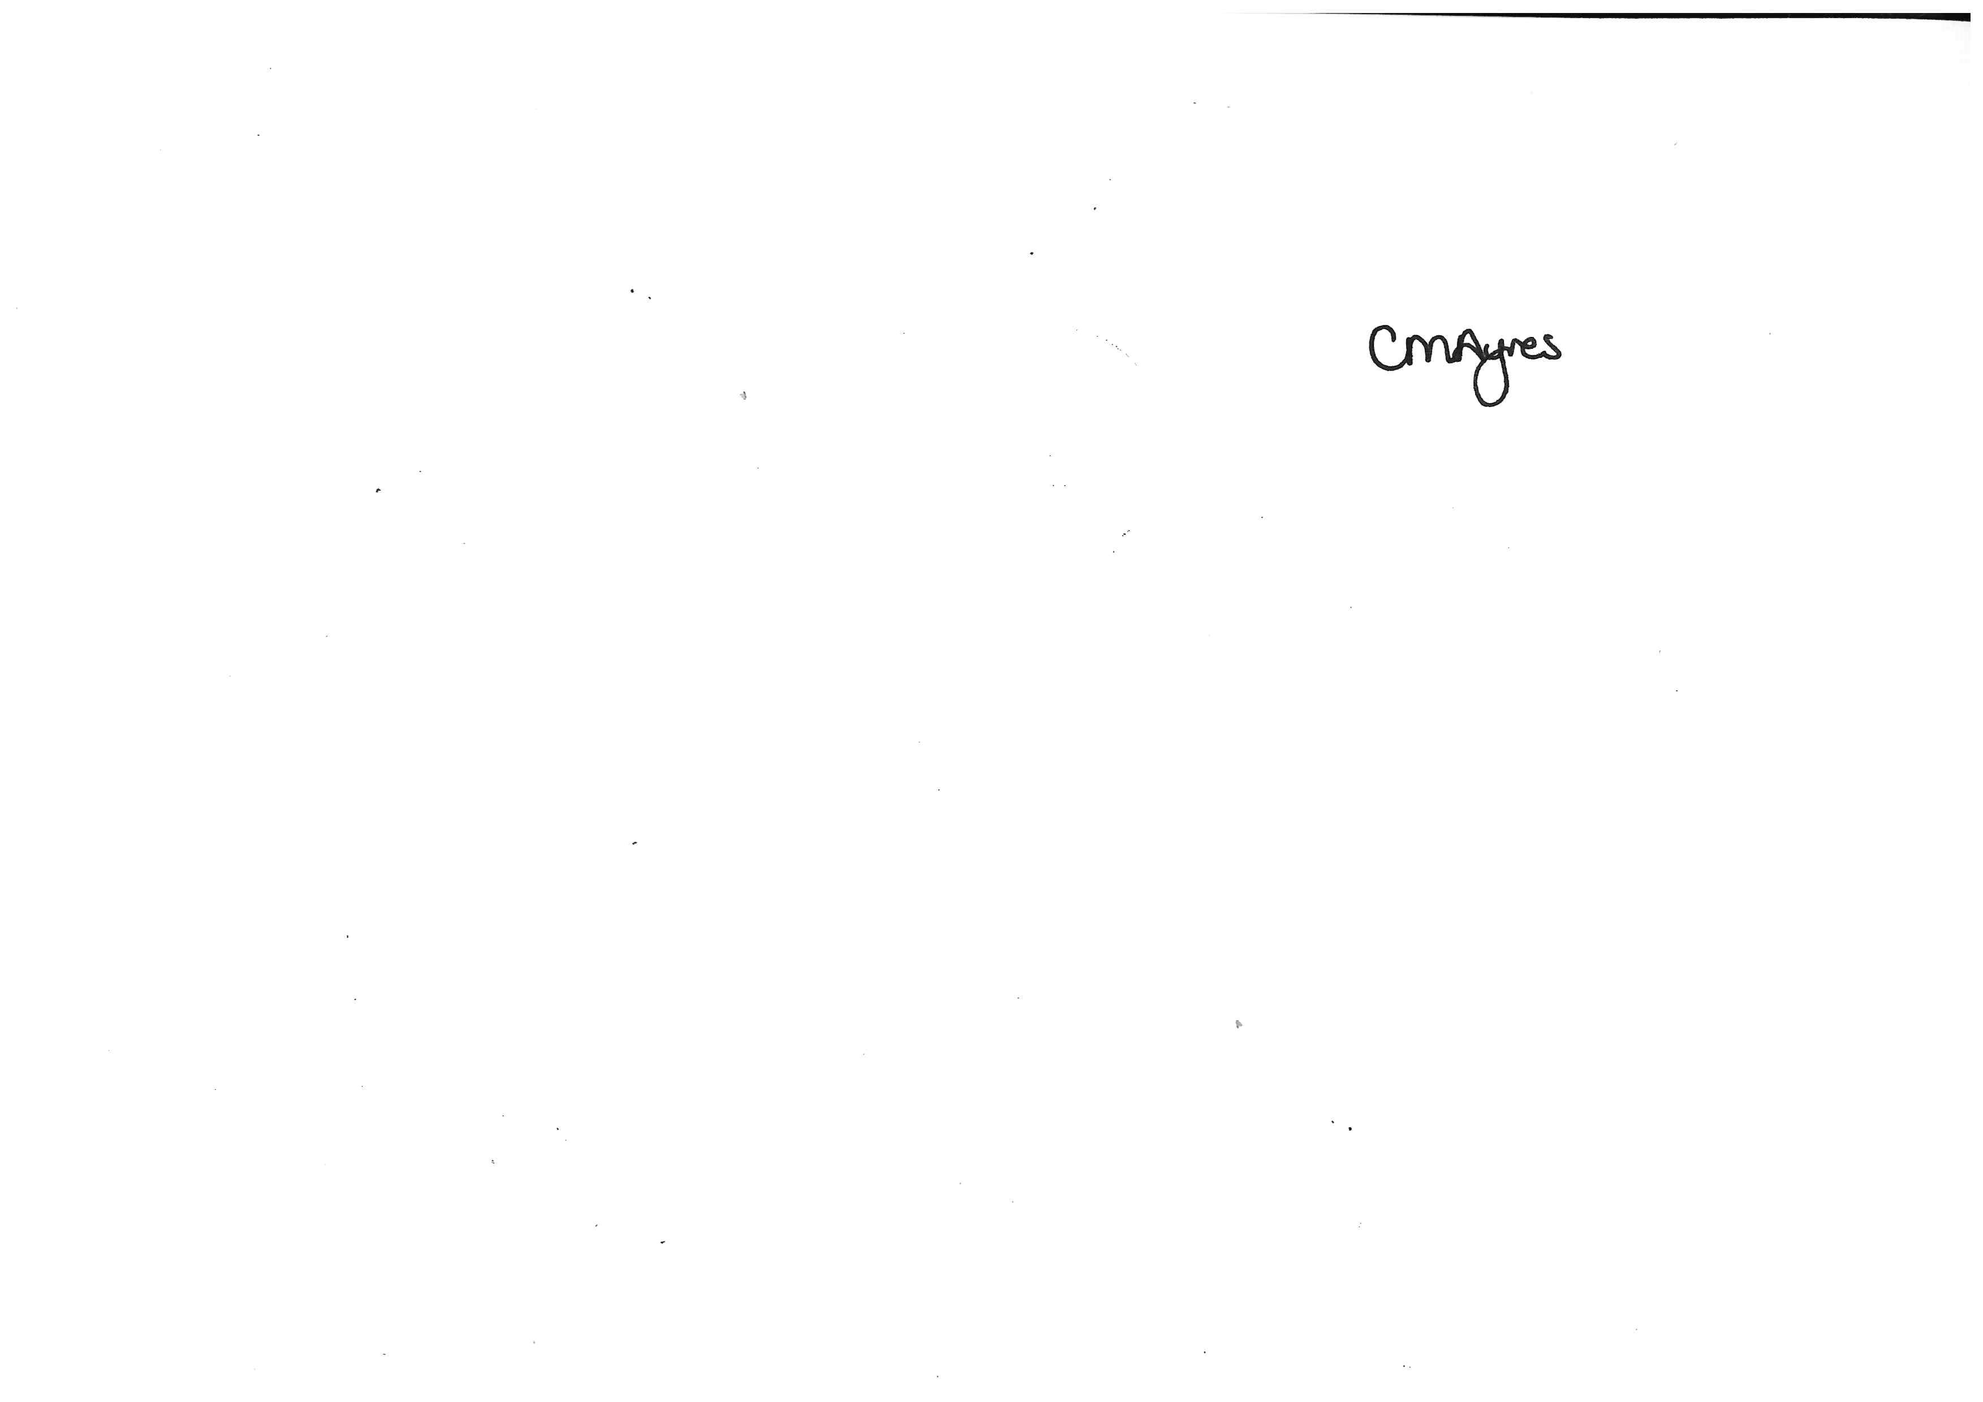

Carey Ayres
Headteacher

Course Information

What Courses are Available?

- A-Levels over a period of two years
- Level 3 BTEC qualifications
- GCSE Maths and English resit. NOTE: This is only available to students studying 3 full time courses.
- All students will take part in a Care, Guidance and Support programme.
- A range of enrichment opportunities are available that all students participate in.

Entry Criteria
Traditional A-Levels

- 5 Grade 9-4 in GCSE subjects
- Grade 5 GCSE in chosen subjects
- Mathematics—A Grade 7 at GCSE is required
- Further Mathematics – A Grade 8 at GCSE is required
- Biology, Chemistry and Physics: – GCSE Trilogy Grade 7/7 or Triple Grade 7 and a Grade 7 in Mathematics. Students with a near miss in Mathematics at Grade 6 will be considered if their score on the GCSE Examination is within 5% of Grade 7
- Computing: A Grade 6 in Mathematics is required
- Social Sciences (Psychology* and Sociology) and Media Studies must have a Grade 5 in English Language or Literature.

Note:
  - Psychology in addition requires a Grade 5 in Mathematics.
  - *Only one of the two Music courses will run. This decision will be taken in consultation with the students opting to take Music.

BTECs/Applied Courses

- Students currently studying a BTEC/Applied course require a Merit to proceed onto the Level 3 course, in addition to 4 other GCSEs 9-4
- To undertake a Level 3 BTEC/Applied Course without having previously studied the subject in Year 11, 5 GCSE grades 9-4 are required

Note: A strong pass is required to study Human Biology — Grades 55

Key Stage 5 Curriculum

The Post 16 Curriculum is broad, balanced and ambitious. The curriculum is both academic and vocational in order to provide first rate transition post 18 either to university or employment/further training. A full suite of A levels is offered alongside a selection of Vocational, Applied and BTEC choices. Please see out prospectus on the website for full details about all the courses we offer.

English and Mathematics GCSE re-take lessons are fully embedded into the students' timetables to best ensure all students leave school with a strong pass in English and Mathematics

Alongside the academic curriculum is an outstanding enrichment programme to prepare our students for their next steps post 18 which includes, UCAS preparation, apprenticeship opportunities, employment, study skills, Oxbridge support, wider careers advice, mental health/stress awareness, current affairs and work experience. In addition to the timetabled enrichment session all Sixth Form students use two of their non-teaching periods to complete additional enrichment activities which may include ‘Directed Study’, completing an Extended Project, supporting our younger students in their lessons, acting as a Year 7 Tutor reading buddy, being part of the Equal Voices programme or even being a ‘Bold Voices’ ambassador and running a project focussing on gender inequality.

Relationship and Sex Education is taught in accordance with the guidelines issued by the local authority and approved by the Local Governing Body, of the school.

The academic curriculum is based around a Faculty structure with Heads of Faculty, Progress Leaders and Subject Leaders linked to a member of the Senior Leadership Team.

All students, regardless of their age, gender, ability and background, are entitled to and will be offered a range of educational opportunities. In order to achieve this, the curriculum will display breadth, balance, relevance, differentiation, progression and continuity.

The needs of students with specific learning and/or behavioural and emotional difficulties are catered for by the Special Educational Needs Co-ordinator (SENDCo) who will liaise with the support services and faculties to make the necessary curriculum arrangements.

A variety of assessment techniques are used- term time tests, internal and external examinations.

Reporting takes place through Progress Reports, a written report and a Parents' Consultation Meeting for each Year.

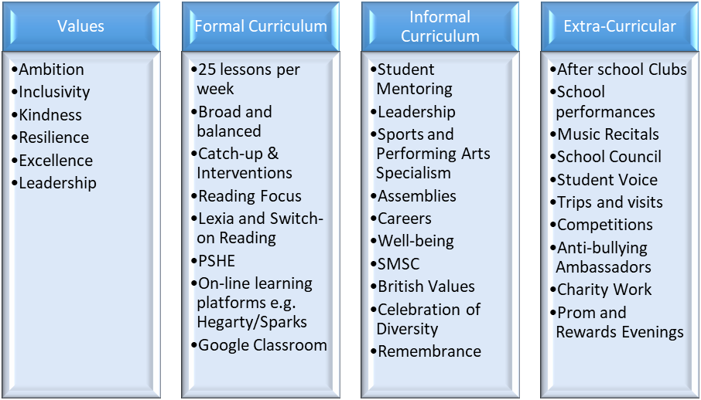

Induction Days - 24th and 25th June 2027

Our Sixth Form Induction is an opportunity for our students to be able to sample lessons and participate in team building activities. Summer preparatory work is also set in order to facilitate an immediate start to the students’ courses in September. Attendance at this event is compulsory.

NB. It must be stressed that no course will run unless numbers are viable. Courses with few students may run with reduced time.

Additional Information

Bursary

The Scheme comprises two parts:

A Vulnerable Bursary (£1,200 an academic year) for those most in need of financial support, i.e. young people who are:

- In Care
- Living independently, having left Local Authority care
- Receiving Income Support or Universal Credit
- Disabled young people in receipt of Employment Support Allowance or Universal Credit who are also in receipt of Disability Living Allowance or Personal Independence Payments.

A Discretionary Bursary available for those in need of finance to help them meet specific costs to enable them to stay in education and complete their courses, e.g. transport, equipment, fieldwork costs.

Further details are available on the school website or see Mr Croft.

Keeping Parents and Carers Involved

We recognise how important Parents/Carers are when it comes to ensuring examination success for our students. We thank you for the work you have already done in order to make the partnership between home and school a successful one and look forward to your continued support and co-operation. We would gladly welcome the attendance of Parents/Carer at our Open Evening to discuss suitable courses for our incoming Year 12 students. We feel that this would be a valuable opportunity for you to meet some of the tutors and to view the facilities we offer to our Post-16 students.

Our prime aim in Post-16 Education is the achievement of academic excellence. Without academic success, a student’s time in Post-16 Education is largely wasted. Therefore, if a student fails to meet our expectations of them we may, regretfully, ask them to leave. We believe that this is in the best interests of the student and of the Sixth Form as a whole. Parents/Carers will be kept constantly informed about the progress of their child, both on an informal basis (telephone, e-mail) and on a formal basis (meetings with Parents/Carers and reports).

Who to Contact


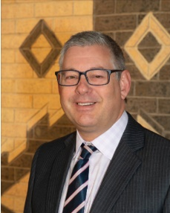

Mr M Croft Mr A Jacques
Deputy Head with Head of Sixth Form
Responsibility for Post 16 Provision

Heads of Subject

Mrs R Walker and Mrs M Howey Art and Design
Mrs J Riley Biology, Chemistry, Physics and Applied Science
Miss L Phillips Business Studies
Mrs S Henderson Drama
Mrs C Cresswell English
Mr J Souter Geography
Mrs K Edwards History
Mrs S Arnold Health and Social Care
Mr J Herbert Information Technology
Ms M Mayes Mathematics
Mr D Ball Music
Mrs C Morgan Media
Mrs K Turnbull Modern Foreign Languages
Mr R Bishop PE
Mrs M Marlow Psychology/Sociology/Criminology
Mr L Charity Technology

Tutors

Mr M Boot Mrs L Halliwell
Mrs K Turnbull Mrs S Arnold
Mrs C Wood Mrs C Cook
Mrs H Tindle Mr J Souter
Mrs M Marlow Mr D Gillott
Miss J Walker Miss A Collins
Miss E Godwin

Sixth Form Office

Mrs Cole

Enrichment

At The Joseph Whitaker School Sixth Form, there is more to life than just gaining qualifications. We want you to achieve your potential and flourish both in and outside of the classroom. Whether you are thinking of going straight to university or full-time employment after the Sixth Form, we recognise the importance of making you stand out from the crowd. That’s why we have an exciting range of enrichment activities for you to take part in to uncover hidden talents and develop new skills.

All students will complete a minimum of 2 hours enrichment per week and can take part in a huge range of activities. Opportunities include:

- In lesson: All of our Sixth Form give one of their study periods to assist younger students in a lesson of their choice Leadership.
- Pastoral Mentoring: Working with a younger student who may be struggling in school.
- Reading Buddy: Working with identified students listening to them read and checking comprehension. It may also involve reading aloud to their buddy.
- After School Club Assistant: Become a fully accredited leader and help out with the running of sports clubs, choirs, musical events, dance clubs, school productions and more.
- Duke of Edinburgh: Many students go onto complete the Gold D of E course. Recent expeditions have included travelling to Norway.
- Be part of the Equal Voices programme, which is run for the students, by the students as they work to represent all students and provide a voice to everyone.
- Being part of the Sixth Form Council. Liaise with teachers, Governors and the local community as part of the Sixth Form Council.
- An annual ski trip to Austria, if there are enough students wishing to particiapte.
- Red Shirts: We have many Sixth Form students who are paid employees, working as lunchtime supervisors.
- First Aid; All Year 12 will take part in a ‘Driver Safety’ Course and CPR training to gaining knowledge and training in these areas.
- Access to and support with a range of exciting Online courses (MOOCS).
- Sixth Form Charity Committee: Each year the students select a local charity and organise events to support the local community.
- Year 12 Work Experience: Students get to gain vital experience working within an area that they may choose to pursue as a career.
- Residential Trips and field trips: These range from a Biology trip to a Geography trip to Lisbon and a cultural visit to Rome.
- A volunteer-based trip to Morocco or Sri Lanka organised by Travelteer – a great experience!
- Extended Project Qualification (EPQ) –Students have the opportunity to gain extra UCAS points through an EPQ. It provides an opportunity for students to extend their abilities beyond the A-level syllabus, develop their independent research skills and prepare for university or their future career.
- HE+, which is a support scheme for Oxbridge potential students

Along with all these opportunities, Year 12 and 13 have one lesson a fortnight dedicated to Enrichment. During this period, the students experience a range of presentations. We have close links with both Nottingham and Nottingham Trent Universities, who speak on a range of issues, including University applications, finance and study skills. We also cover apprenticeship opportunities, mindfulness, revision techniques and safe driving as well as talks from local charities.

Students also have the opportunity once a month to opt into an activity area. Activities include fitness training, current affair debates, university survival cooking classes and learning holiday Spanish language.

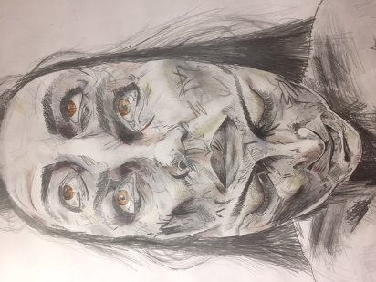
A Level Art

Examination Board: OCR-FINE ART

What Will I learn?

Fine Art provides a solid foundation for the pursuit of all creative disciplines. Within its scope, it teaches the fundamental principles of art and design and enables students to have the confidence and skill to pursuit a multitude of creative pathways. Recent students have gone on to study Illustration at Edinburgh University and Fine Art at Norwich School of Art.

The A-Level Fine Art course is a two-year linear course with an exam at the end of Year 13.

Students follow a dynamic course structure that focuses on skill development, whilst at the same time encouraging the expression of individual creativity.

Students on the course will:

- Improve their investigative, analytical, experimental, technical and expressive skills relating to the Fine Art Principles
- Refine their aesthetic understanding and critical judgement.
- Increase their independence of mind in developing, refining and communicating their own ideas, their own intentions and their own personal outcomes
- Cultivate an interest in, enthusiasm for and enjoyment of art, craft and design
- Increase their knowledge and understanding of art, craft, design and media and technologies in contemporary and past societies and cultures.

How Am I Assessed?

- Oral feedback is delivered on a continual basis in lessons. Students are encouraged to help their peers make informed decisions concerning the development of their work.
- Formal feedback is delivered on a three-week basis and is assessed against the examination assessment criteria.






What Career Options Do I Have?

- Students could decide to continue their artistic studies at university or move into a work-based apprenticeship. Equally, they could decide to further develop their skills and broaden their knowledge of artistic disciplines by completing a foundation course in art and design.
- A Fine Art A Level is the ideal qualification to enable further study in any creative degree. These can include Architecture, Illustration, Product Design, Set Design, Branding, Interior Design, Fashion, Teaching, Textiles and indeed Fine Art to name a few.
- Fine art is defined as an academic subject and makes an excellent accompaniment to a university application.





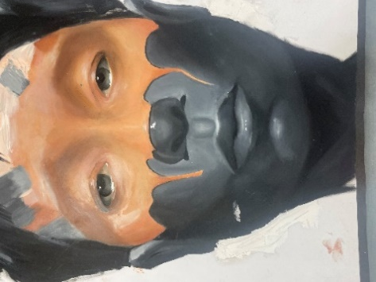

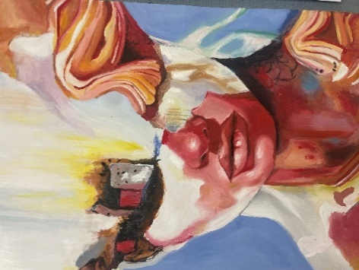

A Level Biology

Examination Board: AQA

What Will I learn?

A Level Unit Title | Description | A Level Unit Title | Description
Biological Molecules | - Carbohydrates  - Lipids  - Proteins  - Nucleic Acids and DNA | Energy transfers in and between organisms | - Photosynthesis  - Respiration  - Nutrient Cycles
Cells | - Cell structure & microscopy  - Cell membranes and transport  - Immune system | Responding to changes | - Nerve function  - Hormone action  - Controlling internal conditions
Exchange of  substances with the environment | - Gas exchange  - Digestion and absorption  - Circulation in plants and animals | Populations, evolution and ecosystems | - Population sampling  - Interdependency  - Changes in population  - Natural selection
Genetics | - Genes and chromosomes  - Genetic diversity and mutation | The control of gene  expression | - Mutations  - DNA technology  - Medical genetics and genetic disorders

How Am I Assessed?

Unit Title | Description | Assessment/Weighting
Paper 1 | Content from Modules 1 to 4  Short and longer answer questions | 2 hours  written exam  35%
Paper 2 | Structured questions and extended response questions, covering theory and practical skills.  Assesses content from modules 5-8 | 2 hours  written exam  35%
Paper 3 | Structured questions and extended response questions, covering theory and practical skills.  Essay question  Assesses content from modules 1 to 8 | 2 hours  written exam  30%
Non-exam assessment - Practical endorsement for biology | Candidates complete a minimum of 12 practical activities to demonstrate competence. Performance is then reported separately to the A Level grade | Non-exam  Reported separately

What Career Options Do I Have?

You may have already made up your mind as to the career path you wish to follow, or you may still be undecided. Possibly you have chosen two or three subjects for next year but are unsure on which others to take. Biology is directly relevant in careers such as Health, Medicine, Working with Animals, Caring for People, Scientific research, Genetics, Forensic Science etc.

Biology is indirectly relevant and valued by employers in many other fields. Many employers believe that the best candidates have a broad background of academic subjects. If you are considering further study after Sixth Form, at College or University, then there are a variety of Biological options including Microbiology, Zoology, Botany and degrees in other subjects that appreciate the value of a diverse academic background.

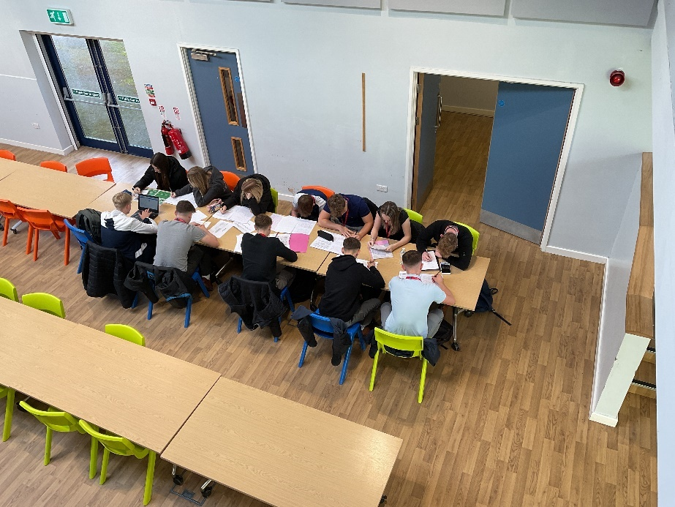

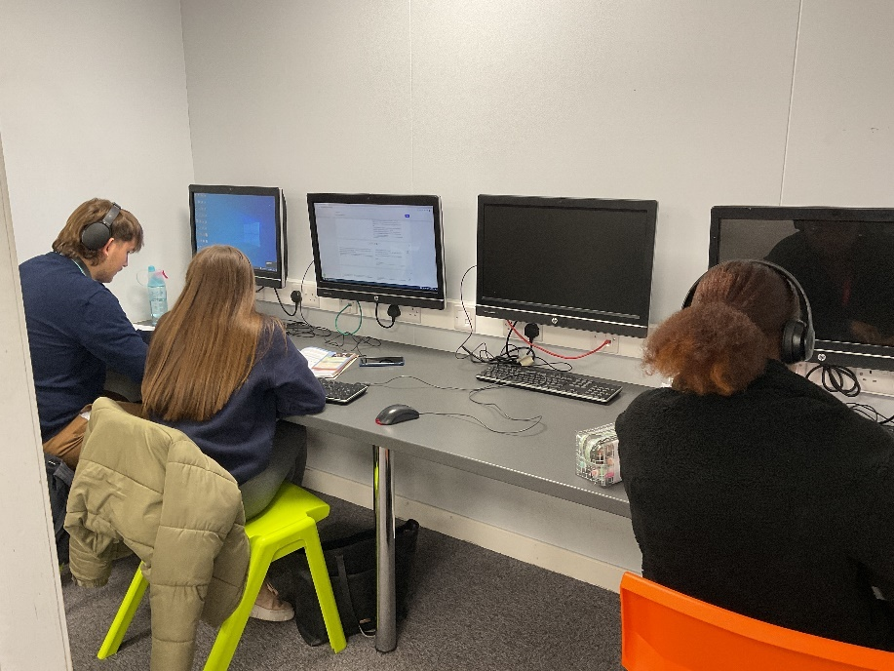

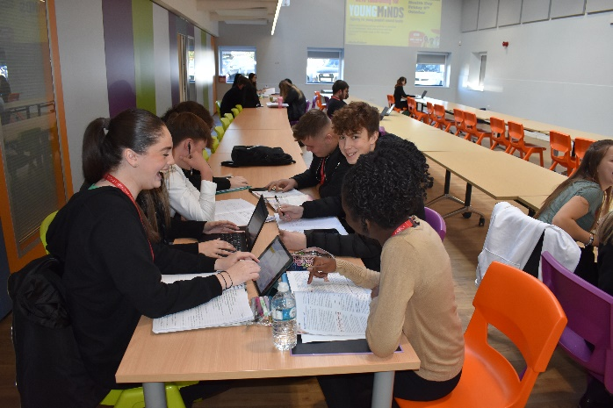
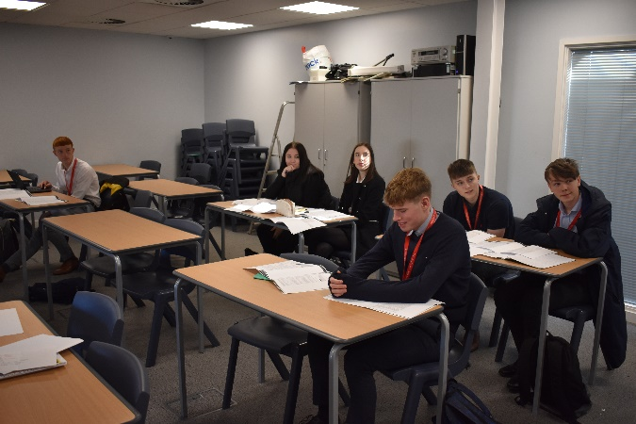
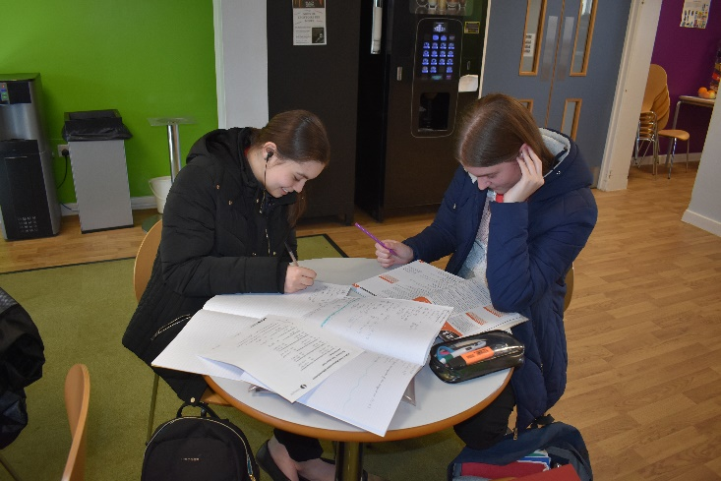

A Level Chemistry

Examination Board: OCR Chemistry A (H432)

What Will I learn?

Atoms, compounds, molecules, equations Amount of substance
Acid-base and redox reactions Electrons, bonding and structure
The Periodic table and periodicity Group 2 and the halogens
Qualitative analysis Enthalpy changes
Basic concepts of carbon chemistry Hydrocarbons
Alcohols and halogenoalkanes Reaction rates and equilibria
pH and buffers Enthalpy, entropy and free energy
Redox and electrode potentials Transition elements
Aromatic compounds Carbonyl compounds
Carboxylic acids and esters Nitrogen compounds
Polymers Organic synthesis
Analytical techniques (Infrared, mass spectroscopy, chromatography, NMR)

How Am I Assessed?

Paper 1- Periodic  table, elements and physical chemistry | Section A – Multiple choice  Section B – Structured questions covering theory  and practical skills.  Assesses content from modules 1, 2, 3 and 5 | 2 hours 15 min  written exam  37%
Paper 2 – Synthesis and analytical  techniques | Structured questions and extended response questions, covering theory and practical skills.  Assesses content from modules 1, 2, 4 and 6 | 2 hours 15 min  written exam  37%
Paper 3 – Unified chemistry | Structured questions and extended response questions, covering theory and practical skills.  Assesses content from modules 1 to 6 | 1 hour 30 min  written exam  26%
Practical endorsement for Chemistry | Candidates complete a minimum of 12 practical activities to demonstrate competence. Performance is then reported separately to the A Level grade | Non-exam  Reported separately

What Career Options Do I Have?

Chemists are very much involved in tackling the problems faced by modern society. On a given day, a chemist may be studying the mechanism for the recombination of DNA, measuring the amount of insecticide in drinking water, developing a biodegradable plastic, comparing the protein content of meats, monitoring and controlling pollution, developing a new antibiotic or analysing a moon rock! In addition, a Chemistry qualification is excellent preparation for careers in medicine, dentistry and veterinary medicine or in the allied health professions.

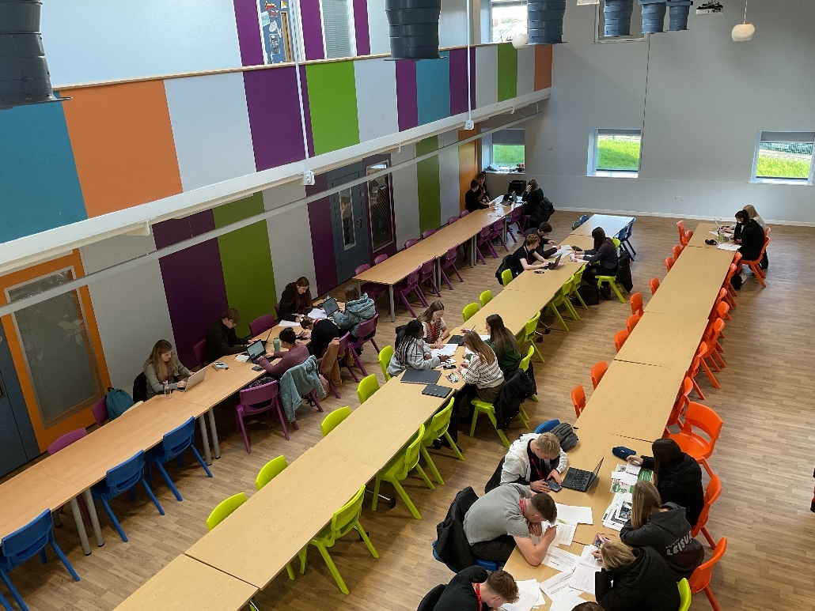

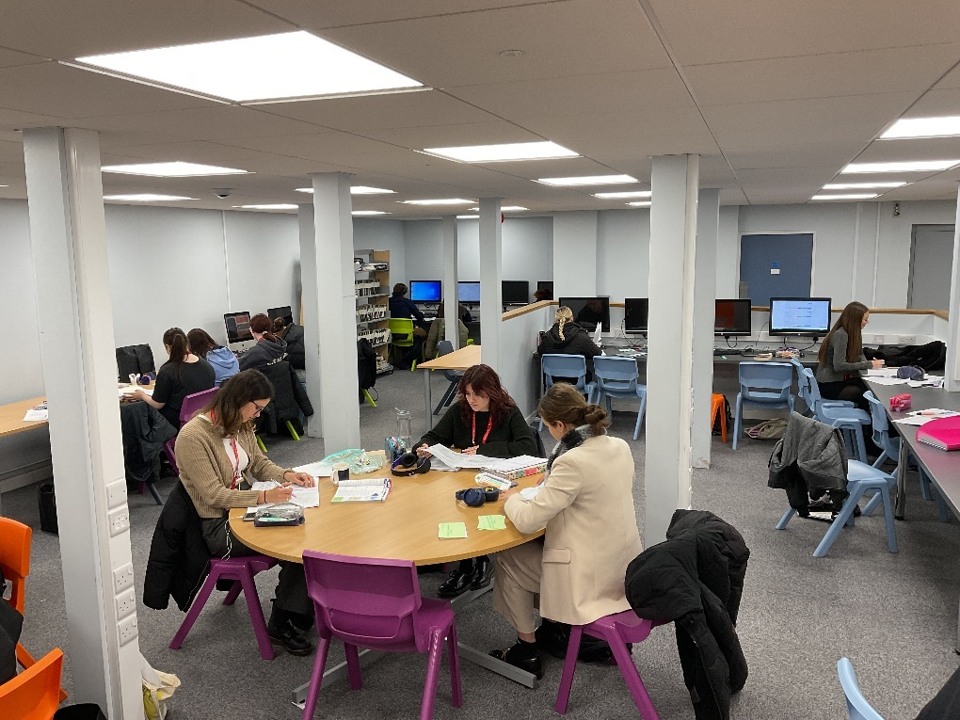

A Level Computer Science

Examination Board: OCR

What Will I learn?

Computer Science is a practical subject where you can apply the academic principles learned in the classroom to real-world systems. It’s an intensely creative subject that combines invention and excitement, and can look at the natural world through a digital prism. The aims of this qualification are to enable you to develop:

- An understanding and ability to apply the fundamental principles and concepts of computer science, including: abstraction, decomposition, logic, algorithms and data representation.
- The ability to analyse problems in computational terms through practical experience of solving such problems, including writing programs to do so.
- The capacity to think creatively, innovatively, analytically, logically and critically.
- The capacity to see relationships between different aspects of computer science .

How Am I Assessed?

You will be assessed through 2 methods; examinations and non-exam assessment.

Components 1 and 2 (Computer Systems and Algorithms and Programming) are externally examined.

Component 3 (Programming Project) are internally assessed and externally moderated through non-exam assessment. You will choose a computing problem and the work that is produced is assessed by a member of staff and then externally moderated by the exam board.

Unit | Weighting
Component 1 – Computer Systems | 40%
Component 2 – Algorithms and Programming | 40%
Component 3 – Programming Project | 20%

What Career Options Do I Have?

The course will prepare you for job roles such as; Computer Games Developer, Forensic Computer Analyst, Computer Games Tester, Robotics Engineer, Database Administrator, Software Developer.


A Level Drama

Examination Board: Eduqas

What Will I learn?

Drama and Theatre is an exciting, enjoyable and challenging subject at 16+. This innovative and creative course introduces students to a wide range of theatre, which includes classical and contemporary texts, incorporating a variety of dramatic styles, theatre companies and practitioners. Students have the opportunity to see a variety of live theatre productions; an integral and exciting part of the course.

The academic content is rigorous and challenging; at the same time the course encourages students to develop presentational skills and confidence, enabling them to converse articulately on many different levels. Students are able to develop their interest in and enjoyment of drama and theatre, through their development as directors, performers, designers and educated spectators.

How Am I Assessed?

Unit Title | Description | Weighting
Component 1  Theatre Workshop | Non- exam assessment: internally assessed, externally moderated | 20%
Component 2  Text in Action | Non- exam assessment: externally assessed by a visiting examiner | 40%
Component 3  Text in Performance | Written examination: 2 hours 30 minutes | 40%

What Career Options Do I Have?

This Advanced Level specification provides opportunities for progression to courses in higher education in all related subjects, including English and Modern Foreign Languages, History and Politics, Psychology, Music and Dance. It is supported by all higher education institutions as an entry qualification in other subjects. Equally, it is a highly enabling subject for students wishing to pursue a career that involves communication such as law, education and the arts and media industries. Business employers, for instance, particularly like to see drama on a prospective employee’s CV, because it suggests a high level of presentational and interpersonal skills which they consider to be vital in today’s competitive working environment.

A Level English Language

Examination Board: AQA

Why Choose AQA English Language A Level?

Unlock the Power of Language – Shape Your Future

The AQA English Language A Level course offers students far more than just reading and writing—it provides a deep and practical understanding of how language works in the real world. From decoding political speeches to analysing digital communication and creating original written work, students develop a critical awareness of the language that surrounds them every day.

Skills That Last a Lifetime

This course is a gateway to mastering essential academic and professional skills. Students will learn how to:

- Analyse and evaluate language with precision and insight
- Craft persuasive and purposeful writing across different genres and audiences
- Understand sociolinguistic issues such as accent, identity, gender, power and representation
- Conduct independent research, including language investigations based on real-world data

These are not just English skills—they are life skills. Students gain confidence in communication, argumentation, interpretation, and critical thinking. They leave the course prepared for the intellectual demands of university and the workplace.

What Will I learn?

Textual Variations and Representations
Children's Language Development
Language Diversity and Change
Language Discourses
Writing Skills
Language Investigation
Original Writing

Unlike literature-focused courses, AQA English Language explores the living language. Students study:

• How children acquire language
• The impact of technology on communication
• How attitudes to language shape society
• The evolution of English over time

How Am I Assessed?

Unit Title | Description | Assessment/Weighting
Paper 1-  Language, the Individual and Society | - Textual variations and representations  - Children's language development (0-11 years)  Methods of language analysis are integrated into the activities | 2 hours 30 min  written exam  100 marks  40%
Paper 2 –  Language Diversity and Change | - Language diversity and change  - Language discourses  - Writing skills  Methods of language analysis are integrated into the activities | 2 hours 30 min  written exam  100 marks  40%
Non-Exam Assessment (Coursework) | - Language Investigation  - Original Writing  Methods of language analysis are integrated into the activities | - Word count: 3,500  - 100 marks  - 20%  - Assessed by teachers  - Moderated by AQA

Versatile and Respected
AQA English Language is highly regarded by top universities and is a flexible A Level choice. It complements subjects like:
Psychology History Sociology
Politics Media Studies Modern Languages
And it opens doors to a wide range of university courses and careers, including:
Law Creative Writing and Publishing Education
Marketing Speech and Language Therapy Communications and PR
Journalism
A Course for Curious Thinkers and Confident Communicators
Whether your future lies in science, humanities, the arts or business, AQA English Language provides a strong academic foundation. It's a course for students who want to think deeply, argue clearly, and understand the world through the lens of language.

Language is power—and with this course, students learn to use it well.

A Level English Literature

Examination Board: AQA
Tragedy. Protest. Power. Voice.
Step into a world of powerful stories and radical ideas. The AQA English Literature A Level isn’t just about reading books, it’s about learning to think independently, challenge assumptions, and communicate with clarity and confidence.
Through the lenses of Tragedy and Political and Social Protest Writing, students explore literature that has shaped—and continues to challenge—the world we live in.

What Will I Learn?

Aspects of Tragedy:
- Othello (Shakespeare) – A brutal and beautiful tragedy of love, jealousy, manipulation, and race.
- Death of a Salesman (Arthur Miller) – A moving critique of the American Dream, masculinity, and failure.
- Selected Poetry by John Keats – Romanticism at its most lyrical and tragic, exploring beauty, death, and the imagination
Political and Social Protest Writing:
- The Handmaid’s Tale (Margaret Atwood) – A chilling dystopia exploring authoritarianism, gender, and resistance.
- The Kite Runner (Khaled Hosseini) – A deeply personal novel exploring guilt, loyalty, and political violence.
- Poetry by William Blake – Revolutionary and visionary, Blake’s poetry challenges injustice, poverty, and oppression.
Unseen Text Study:
Students will also explore unseen extracts of political and social protest writing, developing their ability to analyse unfamiliar material critically, drawing on context, literary technique, and genre awareness. This nurtures adaptability, confidence, and transferable analytical skills.
Coursework: Independent Critical Study
The Non-Exam Assessment (coursework) is a personal, self-directed project; a chance for students to choose their own essay questions in consultation with their teacher.

How Will I Be Assessed?
Unit Title | Description | Assessment/Weighting
Component 1 | - Task 1 - Shakespeare extract  - Task 2 - whole Shakespeare play  - Task 3 - comparison of two texts | 2 hours 30 min  written exam  3 tasks worth 25 marks each  50 minutes per question  Closed book
Component 2 | - Section A - one compulsory unseen question  - Section B - one essay question on a set text  - Section C - one essay question which connects two texts | 2 hours 30 min  written exam  Three hour open book (clean copy) question paper with 3 questions  1 hour per question
Component 3 | - One text must be poetry, one text must be prose  - Each text must be linked to a different section of the AQA Critical Anthology  - Word count for each piece – 1250-1500 | Coursework  20% of A Level  Two pieces of work, each on a different literary text
Where Can English Literature Take You?
This course is highly regarded by universities and works beautifully alongside subjects like:
History Politics Sociology Philosophy Law
Psychology Media Modern Languages Drama and Theatre
Graduates go on to careers in:
Law Journalism Publishing PR Politics
Civil Service Arts, culture and creative industries Teaching and academia
Wherever language matters, English Literature gives students an edge.
Why Study Literature Now?
Whether it’s Othello’s downfall, Offred’s resistance, or Amir’s search for redemption, these stories help us ask and answer the biggest questions of our time. Who holds power? Who resists? What does it mean to be human?
In a noisy world, literature helps us slow down, look deeper, and speak more clearly.
A Course for Independent Thinkers and Brave Readers
If you enjoy storytelling, exploring ideas, debating meaning, and writing with purpose then AQA English Literature A Level is for you.
Because literature doesn’t just reflect society. It challenges it.

A Level French

Examination Board: AQA

What Will I learn?

The A-level French course is an exciting two-year course which has been designed to give students a profound understanding of the mechanics of the French language, French society and the Francophone world.

The course builds on the prior knowledge you have gained at GCSE and allows you to develop the language and the skills necessary to communicate on a range of contemporary and global issues; as well as providing you with an insight into the cultural, social and political life of France and French speaking countries.

Throughout the course, you will get the chance to study a book and a film, and to conduct your own Individual Research Project on your chosen topic and present your findings during your final speaking exam.
Over the course of your A-level in French we will aim to provide you with the opportunity to practise your improved spoken language skills as much as possible in order to increase levels of fluency.

How Am I Assessed?

You are assessed through 3 examinations in Year 13.

Paper | Description | Time
1 | Listening Reading and Translation  This will cover the topics of the course: Aspects of society, artistic culture, Multiculturalism and Political Life | 2 hours 30 minutes
2 | Writing  You will write two essays on the text and film you have studied | 2 hours
3 | Speaking Exam  Topic discussion and Independent Research presentation and discussion | 15 minutes

What Career Options Do I Have?

The study of a foreign language is a key skill in Britain today. It is a proven fact that languages open doors, whether in the business world or when visiting other countries as a tourist. Studying French to a higher level will give you a well-respected qualification, valued by universities. Choosing a language gives you a qualification that is highly regarded by universities across the country. Universities and prospective employers understand that a language qualification gives students a variety of transferable skills that are essential in many degrees and subsequently in the world of work. Previous A-Level students have gone on to study law, history, engineering, medicine and international business. For many students their A-Level in languages has given them the chance to start a new language from scratch as a subsidiary course or spend time abroad during their time at university.

A Level Geography

Examination Board: AQA

What Will I learn?

Students will get the opportunity to: engage with the relationships between human populations over space and time and their physical environment at a variety of scales from local to global, and consider their own role relative to the issues being studied, and the values and attitudes of others including decision makers. Our students will study the following:

Physical Geography

Water & carbon cycles – The major stores of water and carbon at or near the Earth’s surface and the dynamic cyclical relationships associated with them.

Coastal systems & landscapes - Coastal processes, landforms, sea level changes, flooding and protection.

Hazards – The hazards that are posed to human populations in dramatic and catastrophic fashion. Students investigate the many dimensions of the relationships between people and their environments.

Human Geography

Global systems and governance – globalisation; the economic, political and social changes associated with technological and other forces, and how they have been a key feature of the global economy and society.
Changing places – People’s engagement with places, their experience of them and the qualities they ascribe to them.

Contemporary Urban Environments - How towns and cities are changing over space and time.

Key skills learnt: A variety of investigative, cartographic, graphical, applied ICT and statistical skills.
Completion of a geographical fieldwork investigation in a coastal or urban environment in Portugal.



How Am I Assessed?

Unit Title | Description | Weighting
1 | Written examination: 2 hours 30 minutes | 40%
2 | Written examination: 2 hours 30 minutes | 40%
3 | Non- exam assessment: internally assessed, externally moderated | 20%

What Career Options Do I Have?

This Advanced Level specification provides opportunities for progression to courses in higher education in all related subjects, including English and Modern Foreign Languages, History and Politics, Psychology, Music and Dance. It is supported by all higher education institutions as an entry qualification in other subjects. Equally, it is a highly enabling subject for students wishing to pursue a career that involves communication such as law, education and the arts and media industries. Business employers, for instance, particularly like to see drama on a prospective employee’s CV, because it suggests a high level of presentational and interpersonal skills which they consider to be vital in today’s competitive working environment.

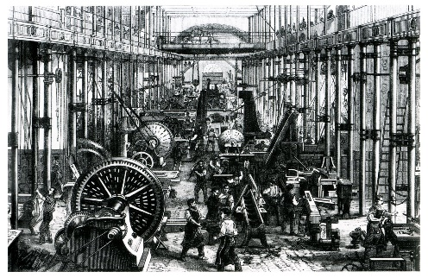
A Level History

Examination Board: AQA

What Will I learn?

You will learn about the USA from the end of the Civil War until its establishment as a Superpower in the post-war era. This is a very broad course which covers social, economic and political affairs including the Gilded Age, isolationism, The Great Depression, international conflict and the Civil Rights movement. You will gain an understanding of how the American political system functions and how the USA developed its standing in the world today.

You will also study modern Britain during a time in which Britain enjoyed a period of post-war affluence and boom, followed by an era of reaction. You will learn about important individuals such as Macmillan, Wilson, Thatcher and Blair and will also examine other factors such as the impact of government policies on industrial relations, trade unions and the nature of the relationship between the state and its citizens. By the end of the course you will be able to demonstrate how issues such as economic performance, party-political reinvention and multiculturalism changed Britain by 2007.
In addition, you will undertake an individual study of standards of living during the Industrial period in Britain focusing on living conditions, wages, mortality rates, nutrition, working conditions and many other areas. You will produce a 3500 – 4000 word essay. This will be a much more independent piece of work and will help you to develop many of the academic writing skills necessary at university.

How Am I Assessed?

Each examined unit has a 2 hours 30 minutes examination at the end of the course. You will have either a source based (paper 2) or interpretation based (paper 1) question worth 30 marks plus two essay questions (out of a choice of three) for 25 marks each.

What Career Options Do I Have?

History is a subject which is highly valued in many careers and by many universities because it helps you to develop a range of skills such as analysis, evaluation, critical reasoning and both oral and written communication. As such it could lead you to careers in Law, Politics, Archaeology, Education and the museum and charity sections among a wide range of others.

A Level Mathematics

Examination Board: AQA

What Will I learn?

Pure Mathematics can be thought of as an extension of GCSE level Mathematics, but some of the ideas behind Applied Mathematics will be new to students. The two applied parts of the course are called Statistics and Mechanics.

The students will study a variety of topics in the Pure part of the course. These include Proof, Differentiation, Integration, Sequences and Series and a deeper understanding of Trigonometry.

Mechanics includes the study of Kinematics, Forces and Motion, Moments and Projectiles.

Statistics includes the study of Probability, Statistical Distribution and Hypothesis testing.

How Am I Assessed?

Year 13

May/June

A2—Pure Mathematics
A2—Pure Mathematics and Mechanics
A2— Pure Mathematics and Statistics

The question paper consists of a number of questions of different lengths, type and mark allocation. Candidates attempt all questions.

The total mark for each paper is 100. Each question paper has a duration of 2 hours.

What Career Options Do I Have?

Engineering, Computing, Finance, Business, Mathematical modelling and Statistics.

“Mathematics is the gate and key of the sciences” (Roger Bacon)

A Level Further Mathematics

Examination Board: AQA

What Will I learn?

This course extends A2 Mathematics and is particularly suited to those thinking of Mathematics / Engineering-based further education. The course follows the same format and has the same proportion of Applied and Pure Mathematics as A2 Mathematics

The standard of Mathematics required is high, a Grade 8 at GCSE is required.

How Am I Assessed?

A2—Further Pure 1

A2—Further Pure 2

A2—Mechanics and Discrete Mathematics

The question paper consists of a number of questions of different lengths, type and mark allocation. Candidates attempt all questions.

The total mark for each paper is 100. Each question paper has a duration of 2 hours.

What Career Options Do I Have?

Engineering, Computing, Finance, Business, Statistics, and Mathematics at University. Some prestigious university courses require you to have a Further Mathematics qualification and others may adjust their grade requirements more favourably to students with Further Mathematics.

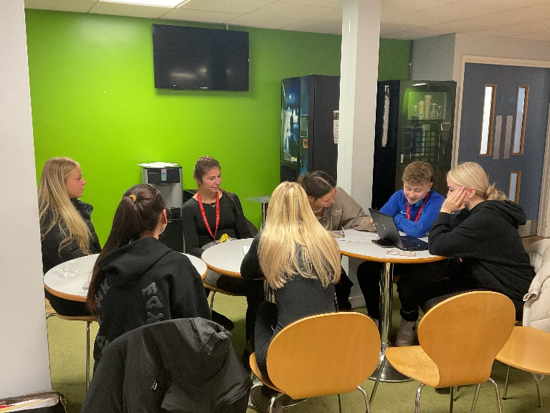

A Level Media Studies

Examination Board: Eduqas (WJEC)

It might be a good idea to get the ball rolling by defining what the term ‘media’ actually means.

Malcolm X famously once said that “the media is the most powerful entity on earth.” In many ways, he was right: from television, film and radio, to what we see on the internet, media is everywhere, and it can entertain as much as it can influence.

What Will I learn?

You will study four areas of the theoretical framework: - media language, media representations, media industries and audiences.

You are required to study media products from all of the following forms: - audio visual, online, radio, gaming and print. This will be done through the study of several set texts provided by the exam board, some of which will feature in the end exam alongside unseen products.

You will build on your study of the theoretical framework and apply in depth study to a cross-media production task specified by the board.

How Am I Assessed?

Component 1 – Media Products, Industries and Audiences Exam (35%)

The examination assesses media language, representation, media industries, audiences and media contexts. It consists of two sections:
Section A: Analysing Media Language and Representation
This section assesses media language and representation in relation to two of the following media forms: advertising, marketing, music video or newspapers.
Set texts covered at A level are: The Times and The Daily Mirror (coverage of the lockdown ‘Partygate Scandal’ in both), Beyoncé's ‘Formation’ video, Sam Fender’s ‘Seventeen Going Under’ video, Tide’s 1950s washing powder advertisement, the Superhumans advertisement, and the Kiss of a Vampire film poster. Several ‘unseen’ texts are also studied from each of these study areas.

Section B: Understanding Media Industries and Audiences
This section assesses students’ understanding of the media industry, including funding, ownership and regulation, and audiences.
Set texts covered at A level are: The Times and The Daily Mirror, I, Daniel Blake (film), Black Panther (film), the Assassin’s Creed Franchise and ‘Have you Heard George’s Podcast?’.

Component 2 – Media Forms and Products in depth Exam (35%)

The examination assesses media language, representation, media industries, audiences and media contexts. It consists of three sections:

Section A – Television in the Global Age
In this section students explore set episodes of the shows ‘Peaky Blinders’ and ‘The Bridge’.
Section B – Magazines: Mainstream and Alternative Media
In this section students explore the historical magazine ‘Woman’s Realm’ and the contemporary Independent magazine, ‘Huck’.
Section C—Media in the Online Age
In this section students explore the blogger, ‘JJ Olantunji aka KSI’ as well as the online magazine, ‘Attitude’.

Component 3 – Cross Media Coursework Production (30%)

An individual cross-media production based on two forms in response to a choice of briefs set by WJEC, applying knowledge and understanding of the theoretical framework and digital convergence.

Students can typically choose between four areas: TV production, Music Marketing, Film Marketing and Print Production. Briefs are set in terms of audience, industry and genre, but within each brief typically students will choose between producing an audio-visual piece, a print production, a website, a radio segment/podcast, or marketing materials such as posters and DVD covers.

What Career Options Do I Have?

Media studies can be useful in a range of careers including marketing, sales and advertising, broadcast media, business, politics, performing arts, journalism and publishing, and leisure sport and tourism.

We live in an age in which the media industry is ever growing and more and more influential. Media graduates are highly desirable and will be the influencers of the future.









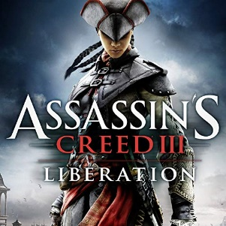







A Level Music

Examination Board: Eduqas

What Will I learn?

This course allows learners to pursue their own musical interests. You will develop skills in performance, composition and appraising, whilst choosing to specialise in either performing or composing. The fascinating, broad range of study will cover both popular and classical music, including the symphony, twentieth-century music and a choice of Rock and Pop, Musical Theatre or Jazz. In addition to such skills of musicianship, the course develops imagination, fosters creativity and you will develop as an effective, independent learner and as a critical and reflective thinker.

How Am I Assessed?

Learners choose Option A or Option B for both component 1 and 2 to make up 60% of the marks).

Component 1 - Performing  Non-exam assessment (visiting examiner) | Option A (35%):  3+ performances (total duration: 10-12 minutes) with at least 1 performance as a soloist and with 2 performances in contrasting styles  Option B (25%):  2+ performances (total duration: 6-8 minutes)
Component 2 - Composing  Non-exam assessment | Option A (25%):  2 compositions (total duration: 4-6 minutes):  1 in response to a set brief, reflecting the musical techniques of the Western Classical Tradition and  1 free composition  Option B (35%):  3 compositions (total duration: 8-10 minutes):  1 in response to a set brief, reflecting the musical techniques of the Western Classical Tradition,  1 reflecting stylistic characteristics of your choice of rock, pop, musical theatre, jazz or twentieth- or twenty-first-century music  1 free composition



Component 3 - Appraising  Written examination  2 hours 15 mins  40% | Three areas of study:  A: The Western Classical Tradition (The Development of the Symphony 1750-1900)  Two set works – one for detailed analysis and one for general study  Haydn – Symphony No. 104 in D major, ‘London’  Mendelssohn – Symphony No. 4 in A major, ‘Italian’  A choice of one from:  B: Rock and Pop  Pop, rock, soul, funk, disco, folk, country, heavy metal, punk, folk-rock and progressive rock  C: Musical Theatre  Richard Rodgers; Leonard Bernstein; Stephen Sondheim; Claude-Michel Schönberg; Andrew Lloyd Webber; Stephen Schwartz.  A study of six composers whose work includes Les Misérables, Wicked, Into the Woods, Sweeney Todd, The Phantom of the Opera, Joseph and The Sound of Music.  D: Jazz  Ragtime, Dixieland, early jazz, big band, swing, be-bop and cool jazz  A choice of one from:  E: Into the Twentieth Century  Poulenc - Trio for Oboe, Bassoon and Piano, Movement II  Debussy - Three Nocturnes, Number 1, Nuages  F: Into the Twenty-First Century  Thomas Adès - Asyla, Movement 3, Ecstasio  Sally Beamish - String Quartet No. 2 (Opus California) Movements 1 (Boardwalk) and 4 (Natural Bridges)  Questions:  1. Set work analysis with a score  2. Extended responses on wider context  3. Unprepared extracts of music with and without a score  4. Comparison questions  This component includes a listening examination.

What Career Options Do I Have?

A level Music is a highly-regarded subject, either alongside other creative courses or in demonstrating a broader range of skills next to Science, Maths or other non-creative subjects.

Whilst Music can be a useful subject for Arts and Media courses at university, it is also an excellent way of proving you are a learner with a diverse range of skills and understanding for any university degree. Of course, the most obvious degree pathway is going on to a degree in Music, which can lead to a range of exciting career options, including becoming a professional musician, composer, sound technician, music therapist, a teacher, or a private tutor. Jobs that are less directly related a Music degree, but where a Music degree would be very valuable include Arts Administration, and work in radio, theatre, music technology and events management.

A Level Physical Education

Examination Board: Edexcel Pearson

What Will I learn?

The theoretical knowledge of the factors that underpin sport.

- The understanding of how physiological and psychological responses affect performance
- Applied anatomy and exercise physiology
- Applied skill acquisition
- The biomechanical movement analysis of sports performance
- The understanding of the key socio-cultural factors that influence people’s participation
- The understanding of how physical activity can improve health and fitness.

How Am I Assessed?

A keen interest in sport and participation at competitive level throughout the duration of the A level is a key requirement for this course as students will assessed in a practical performance as a player or a coach (15%) as well as complete a performance analysis and a performance based development plan. (15%).

Alongside this you be assessed in two written exams, Scientific Principles of Physical Education (40%) and Psychological and Social Principles of Physical education. (30%)

What Career Options Do I Have?
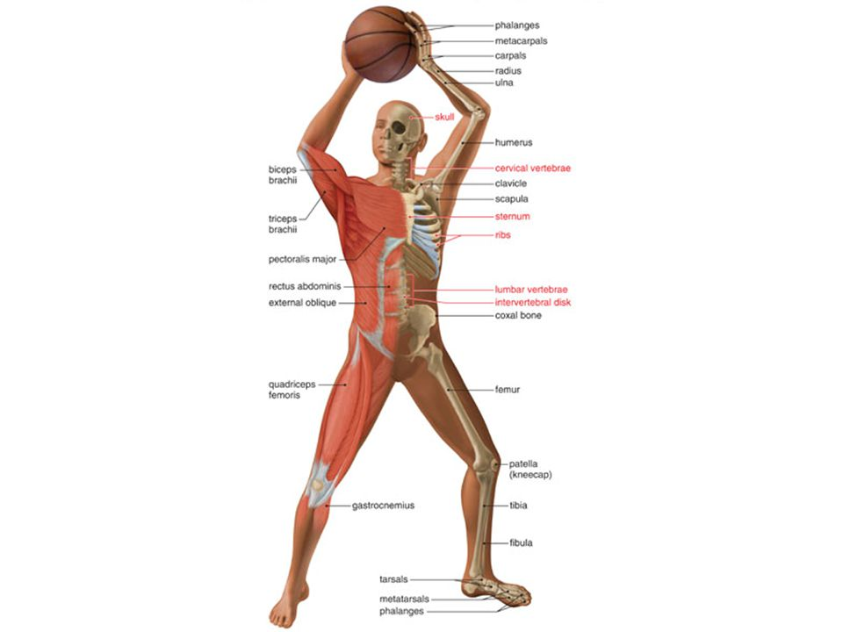
- Exercise and Fitness Instructor
- Sports Journalism
- Sports Scientist
- Sports Coach/PE Teacher
- Sports Physiotherapy
- Sports Performance Analyst

A Level Physics

Examination Board: AQA
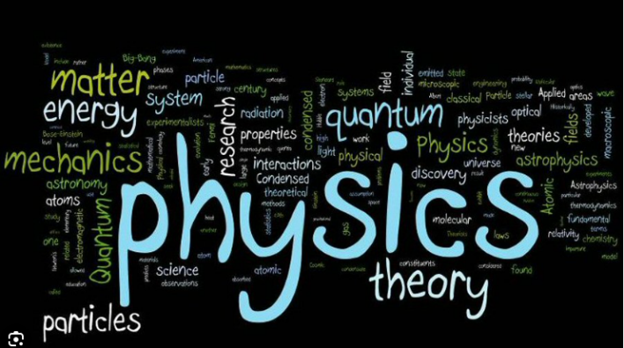
What Will I learn?

Measurements and their errors (Throughout)
Particles and radiation (Year 12)
Waves (Year 12)
Mechanics and materials (Year 12)
Electricity (Year 12)
Further mechanics and thermal physics (Year 13)
Fields and their consequences (Year 13)
Nuclear physics (Year 13)
Option choice - In year 13 you will study either Astrophysics, Medical Physics, Engineering Physics or Turning Points in Physics

How Am I Assessed?

Unit Title | Description | Weighting
Paper 1 | Modules 1-5 and Periodic motion. Short and long  answer questions with 25 multiple choice questions about content | 2 hours  written exam  34%
Paper 2 | Modules 6-8. Short and long answer questions with 25 multiple choice questions about content | 2 hours  written exam  34%
Paper 3 | Section A – Compulsory section; practical skills and data analysis  Section B – assessment of optional module | 2 hours  written exam  32%
Non-exam assessment - Practical endorsement for physics | Candidates complete a minimum of 12 practical activities to demonstrate competence. Performance is then reported separately to the A Level grade. | Non-exam  Reported separately

What Career Options Do I Have?

Engineering Astronomy Robotics
Renewable energies Computer science Communications
Sports technology Nanotechnology Construction
Publishing Physicist Nuclear engineer
Geotechnician Electrician Quantum physicist
Airline pilot Medical physicist Lawyer
Radiographer Ministry of Defence engineer

Plus many more!


A Level Politics

Examination Board: AQA

What Will I learn?

The A-level politics course consists of three areas: UK government and politics, US government and politics with a comparison of the two, and finally political ideologies.

For both the UK and US section of the course, we will look to understand the structures and pitfalls of both political systems, whilst undergoing a continuous comparison of the two. Included in this we will look at the structure and impact of key pieces of legislation, the structure and role of UK Parliament/ US House of Representative and Senate, key political roles and figures and also the development of democratic rights throughout the 20th century to the modern day.

Further, we will look at key post-war elections in the US and UK, looking at how these were won and lost and how this impacts politics today. In addition to this, it is understood that you will have contemporary understandings of political structures and events, meaning there will be an ongoing focus on what is happening in the news in the current day.

For the ideologies section of the course, we will look at the political philosophies that underpin our political movements and parties. These will include:

- Liberalism
- Conservativism
- Socialism
- Anarchism

We will then look to apply these to current political trends.

How Am I Assessed?

You will have three examined units, each consisting of 2 hours at the end of the course. In each exam will be the following:

- Three 9-mark knowledge-based questions.
- A 25-mark source-based question.
- A 25-mark essay which evaluates a political statement.


What Career Options Do I Have?

Politics is a subject which is highly valued in many careers and by many universities because it helps you to develop a range of skills such as analysis, evaluation, critical reasoning and both oral and written communication. Careers that link directly to politics include:

- Political assistant
- Government social research officer
- Policy officer
- Political risk analyst
- Public affairs consultant
- Civil Service Fast Streamer.

Skills highly relevant to a politics A-level include:

- Teacher or lecturer
- Journalist
- Public relations officer
- Human resources officer
- Local government officer
- Marketing executive.



A Level Product Design

Examination Board: AQA

What Will I learn?

The AQA Product Design specification is a two-year course that provides a continued progression of knowledge, understanding and skills built and studied at GCSE. The qualification is linear which means that students will sit all their exams and submit all their non-exam assessment at the end of the two-year course.

This creative and thought-provoking qualification gives students the practical skills, theoretical knowledge and confidence to succeed in a number of careers. Especially those in the creative industries.

Students will investigate historical, social, cultural, environmental and economic influences on design and technology, whilst enjoying opportunities to put their learning in to practice by producing innovative, relevant prototypes of their chosen products gaining a real understanding of what it means to be a designer, alongside the knowledge and skills sought by higher education and employers.

Within the course, students will visit local businesses, factories and Universities to improve students’ understanding of industrial practices and the design industry.

Students choosing the course will:

- Identify market needs and opportunities for new products and use creativity and imagination when applying iterative design processes to develop and modify designs. To design and make prototypes that solve real world problems and are suitable for commercial manufacture, considering user wants, needs, aspirations and values.
- Take risks, showing innovation and enterprise while considering their role as a responsible designer.
- Be able to create and analyse design concepts and use a range of skills and knowledge from other subject areas, including mathematics and science, to inform design decisions and the application or development of technology.
- Demonstrate a high level of literacy and numeracy throughout their coursework and examination.
- Develop a critical understanding of the wider influences on design and technology, including cultural, economic, environmental, historical and social factors.
- Be able to work collaboratively to develop and refine ideas, responding to feedback from users, peers and expert practitioners.
- Develop an in-depth knowledge and understanding of materials, components and processes associated with the creation of products that can be tested and evaluated in use.
- Develop intellectual curiosity about how the design and manufacture of products and systems and their impact on daily life and the wider world.
- Enhance their IT skills to support design and development through the use of Pro Desktop, Adobe Photoshop, 2D Design and Google Sketch-up in order to improve their skills for further education in the design industry.
- Design and create Projects to briefs that are open and therefore could link to product design, architecture, interior architecture, furniture design, graphic design etc.

How Am I Assessed?

Description | Weighting
Technical principles  (Theory) | 30% of A-level  Written exam: 2 hours and 30 minutes - 120 marks  Mixture of short and extended response questions.
Designing and making principles based on Analysing products: (Theory) | 20% of A-level  Written exam: 1 hour and 30 minutes - 80 marks  Section A: 6 short answer questions analysing products  Section B: Mixture of short and extended response questions.
Independent Design and Make Project (Coursework practical Project) | 50% of A-level  Design and make project - 100 marks  Digital portfolio with photographic evidence of a final product/prototype.

What Career Options Do I Have?

The course provides students with a wide range of options following completion, here are a few;
Product design, Graphic Design, Architecture, Interior Architecture, Architectural Technology, Industrial Design, Furniture Design, Automotive and Aviation Design, Landscape Architecture, Set Design, Theatre Design, Design Engineer, Animator, Illustrator, Exhibition Designer, CAD Designer, Furniture Design Technicians etc. the possibilities are endless.

Examples of possible Products design work/projects:
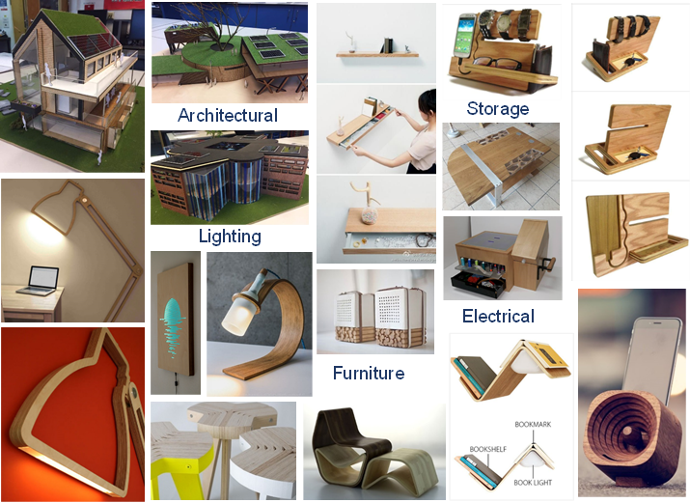

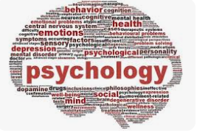
A Level Psychology

Examination Board: AQA

What Will I learn?

Psychology is the study of people, behaviour and the mind. It has recently been reclassified as a science subject, and this is reflected in the A-Level curriculum.

Psychology is a broad subject, with many different areas and a number of different approaches towards explaining behaviour. Not all psychologists agree with each other!

Psychologists observe human behaviour, create theories to explain the behaviour, and then carry out research to test these theories.

Psychology is a challenging subject, requiring commitment and hard work. Ultimately though, the hard work is rewarded with a deeper understanding of people and society and perhaps even yourself.

How Am I Assessed?

Paper 1 - In this module, we look at some the main approaches in psychology: Social Influence, Memory (Cognitive) and Attachment (Developmental) and Psychopathology. The approaches are different fields of psychology, each with its own explanations of human behaviour. This exam will be taken at the end of Year 13 and will be worth 33.3% it is 2 hours in length.

Paper 2 - Here we study the areas of Approaches in Psychology, Biopsychology and Research Methods. You will learn about the different research methods psychologists use to investigate behaviour. This exam will be taken at the end of Year 13 for and will be worth 33.3% it is 2 hours in length.

Paper 3 - This module develops the knowledge of research methods from Year 12, and also looks at ethical issues raised by psychological research and looks at various issues and biases in psychology. The exam is worth 33.3%. The topics and applications take psychological theory, and apply it to a real world issue. These include: Schizophrenia, Forensics , Gender and Issues and Debates. The exam is worth 33.3% it is 2 hours in length.

All papers consist of short answer questions, multiple choice and 16 mark essay type questions

What Career Options Do I Have?

Psychology can be useful in a wide range of careers that involve dealing with people e.g. teaching, social work, police, business, management and the health service etc. Specific careers in psychology are: forensic, occupational, educational, clinical psychology and different kinds of therapy and counselling.

A Level Religious Studies


Examination Board: AQA

What Will I learn?

Why Study Ethics and Philosophy?

- Deepen Understanding of Humanity:
Ethics and Philosophy introduce students to the core questions about existence, purpose and morality that have been discussed for millennia. Students not only learn about various religious beliefs but also the philosophical concepts that underpin and challenge these beliefs.
- Develop Critical Thinking Skills:
Navigating the intricate arguments and counterarguments in this field fosters the development of analytical and critical thinking skills - assets in any professional or academic setting.
- Enhance Communication Abilities:
Engaging in debates and discussions on ethically charged topics teaches students to articulate their views convincingly and respectfully, an indispensable skill in both personal and professional lives.
- Encourage Empathy and Open-mindedness:
Exposure to a wide array of beliefs and ethical systems allows students to appreciate diverse perspectives, promoting a culture of mutual respect and understanding.

Examples of some of the topics covered.

Philosophy: Existence of God, Evil and suffering, Religious Experience, language, life after death

Ethics: How we make moral decisions, ethical issues (abortion, euthanasia, war, poverty, animal ethics, stealing etc), what is the meaning of right and wrong, conscience, freewill and determinism

How Am I Assessed?

Two written exam papers at the end of Year 13.

What Career Options Do I Have?

Relevance for Jobs and University:

- Broad Career Pathways:
The skills acquired are invaluable in a vast range of careers. Journalism, law, social work, counselling, teaching, international relations, and even in the corporate world where ethical decision-making is crucial, the insights from a philosophy and ethics background can set you apart.

- Foundation for Multiple Disciplines at University:
Many courses in the humanities, social sciences, and even some natural sciences can benefit from a background in ethics and philosophy. Subjects like anthropology, sociology, psychology, political science, and more have overlaps with the critical thinking and ethical considerations covered in the subject.
- Preparation for Life:
Whether or not students pursue a career directly related to ethics and philosophy, the moral and ethical challenges faced in personal and professional lives will be better navigated with a foundation in philosophical and ethical reasoning.

Join us in exploring the profound questions of life, ethics, and the intricacies of human beliefs. Enrich your perspective and prepare for a future where understanding and navigating the moral compass of society is more relevant than ever.



A Level Sociology

Examination Board: AQA

What Will I learn?

Sociology studies human behaviour in a different way from other academic approaches. Sociologists look at social behaviour and emphasise the role of culture. They are particularly interested in understanding the ways in which society influences and shapes our lives. Sociology is both thought provoking and challenging because it forces people to rethink some of their common-sense views and assumptions. By studying Sociology you will gain a greater understanding of society and it will help you make sense of your own experiences within it. The topics we will study in depth are Education, Family and Households, Media, Crime and Deviance and Sociological Theories and Methods. It considers how belonging to different groups in society i.e. different class, gender and ethnicity can affect your chances in educational achievement. How these groupings influence crime rates and deviant behaviour.

How Am I Assessed?

Paper 1 - Education and Methods in context and Research Methods. This exam will be taken at the end of Year 13, it is worth 33.3% and is 2 hours in length.

Paper 2 - Topics in Sociology: the family and households and Media. This exam will be taken at the end of Year 13, it is will be worth 33.3% and is 2 hours in length.

Paper 3 - Crime and Deviance with Theory and Methods. This exam will be taken at the end of Year 13, it is worth 33.3% and is 2 hours in length.

All papers consist of short answer questions, 10, 20 and 30 mark essay type questions.

What Career Options Do I Have?

Sociology can be useful in a wide range of careers that involve dealing with people, working with groups and organisations e.g. teaching, social work, police, business, management and the health service etc. Specific careers in sociology are: sociologist working for the government and criminology, lecturing in sociology and the social sciences.

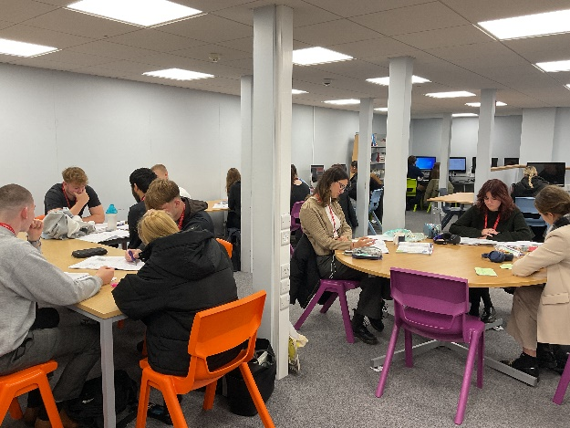

A Level Spanish

Examination Board: AQA

What Will I learn?

Break down barriers—choose Spanish.

Choosing an A Level in Spanish will appeal to those students who wish to broaden their existing knowledge of the language whilst helping them on their journey to both university study and the world of work. You will learn more about the mechanics of the language through grammar, vocabulary and translation. However, language learning is so much more than just words! You will gain a real insight in to Spain and Spanish people and the festivals and customs which make up Hispanic culture. Learning a language at this level really is the route to breaking down barriers and discovering new horizons.

Through A Level Spanish you will study a broad range of interesting and engaging issues in the world today such as immigration, cyberspace and political regimes. You will also study a novel and a film. Furthermore, you will get the opportunity to research an area of particular interest as part of an individual research project. Through these topics you will be developing any employer’s dream skills of analysis, independent skills, prediction, evaluating and improving upon verbal and written communication.

Over the course of your A-level in Spanish we will aim to provide you with the opportunity to practise your improved spoken language skills as much as possible in order to increase levels of fluency.

How Am I Assessed?

You are assessed through 3 examinations in Year 13.

Paper 1 - Listening Reading and Translation. This will cover the topics of the course: Aspects of society, Artistic culture, Multiculturalism and Political Life. This is a written exam for 2 hours 30 minutes.
Paper 2 - You will write two essays on the text and film you have studied. This is a written exam for 2 hours.
Paper 3 - Based on your independent research project. Topic discussion and Independent Research presentation and discussion. This is a speaking exam for 15 minutes.

What Career Options Do I Have?

The study of a foreign language is a key sought after skill in Britain today. It is a proven fact that languages open doors, whether in the business world or when visiting other countries as a tourist. Studying Spanish to this level will give you a well-respected qualification, valued by universities, along with an improving fluency in the language. Languages are a highly regarded qualification by universities across the country. Universities and prospective employers understand that a language qualification gives students a variety of transferable skills that are essential in many degrees and subsequently in the world of work. Previous A-Level students have gone on to study law, history, engineering, medicine and international business. For many students their A-Level in languages has opened the door to a University of their choice and has given them other incredible opportunities such as starting a new language from scratch as a subsidiary course or spending a year abroad as an integral part of their University course.

BTEC National Extended Certificate

in Music Performance

Examination Board: Pearson/Edexcel

What Will I learn?

The EDEXCEL BTEC Level 3 National Extended Certificate in Music Performance is an exciting course designed for students who would like to pursue a vocationally relevant qualification in the music sector. The course gives students an understanding of the vital skills to start a professional career or move on to further study, and an insight into employment opportunities available. It is equivalent in size to one A level, with equivalent UCAS points.

How Am I Assessed?

The EDEXCEL BTEC Level 3 National Extended Certificate in Music Performance is a 360-credit qualification that consists of three mandatory unit plus one optional unit. Half the units are internally assessed and half are externally assessed.

Unit | Mandatory Unit | Credit | Level
1 | Practical Music Theory and Harmony | 90 | 3
2 | Professional Practice in the Music Industry | 90 | 3
3 | Ensemble Music Performance | 120 | 3
 | Optional Units
4 | Composing Music | 60 | 3
5 | Music Performance Session Styles | 60 | 3
6 | Solo Performance | 60 | 3
7 | Improvising Music | 60 | 3

What Career Options Do I Have?

The BTEC Music course is geared for students wishing to pursue various careers in music including performing, composing, music production, music/event management, music broadcasting/journalism and the wider creative industries. The rigour of the course will provide the learner with the relevant qualification base to study at university or music conservatoire. Students can choose to apply for university courses, conservatoires or start an apprenticeship/job in the sector after completing their studies. Careers where music is directly related to the job could include Music Therapist, Musician, Teacher and Sound Technician. Jobs where studying Music could be helpful are: Arts Administrator, Event Manager, Theatre Stage Manager, Sales, Tour Manager, Merchandiser and Public Relations Officer.



Cambridge Technical Extended

Certificate in Business

Examination Board: OCR

What Will I learn?

The Cambridge Technical Extended Certificate in Business offers you the opportunity to investigate how real businesses actually operate.

Unit 1

You will look at a range of different types of business and business structures, and explore how the ownership of a business and its objectives are interrelated. You will understand the legal, financial, ethical and resource constraints under which a business must operate and how these can affect business behaviour. You will explore ways in which businesses respond to changes in their economic, social and technological environment, and the necessity for a business to plan. You will learn how to assess business performance.

Unit 2

This unit will cover the skills and understanding needed to work effectively within a business environment. This includes arranging meetings, working with business documents, making payments, prioritising business activities and communicating with stakeholders. The way that these activities are dealt with will vary according to the specific business protocols in place. Some of these will be specific to a functional area; however, many are common to almost all job roles.

Unit 4

In this unit you will learn the purpose, methods and importance of communication in business and the appropriateness of different forms of communication for different situations. You will develop the skills that will help you create a rapport with customers and have the opportunity to practise and develop your business communication skills. You will also learn about the legal constraints, ethical and security issues that affect how businesses store, share and use information.

How Am I Assessed?

There are 3 Mandatory Units and 2 Optional units. Units 1 and 2 are mandatory and are assessed by examination. Unit 4 is also mandatory and is assessed by coursework. The remaining 2 option units are assessed by coursework and exam.

What Career Options Do I Have?

This course offers opportunities for students who are interested in the world of business and who may have career ideas in banking or finance. It provides a firm foundation for study at degree level – past students have often taken this route into Higher Education, particularly into Business related courses such as International Business, Accounting and Economics. Use of the Internet and ICT in general are encouraged for key skill purposes.

BTEC National Extended Certificate

in Sport

Examination Board: Pearson/Edexcel

What Will I learn?

Equivalent in size to one A Level. This qualification is designed to support progression to higher education taken as part of a programme of study that includes other appropriate BTEC Nationals or A Levels.

In the level 3 BTEC National Extended Certificate in Sport you will study 4 different units from a wide range of topics. Within these units you will develop an understanding of applied anatomy and exercise physiology and how physical activity can improve your health and fitness through classroom and practical based learning. In additional to these units your will acquire knowledge of the sports industry.

How Am I Assessed?

You will be assessed in a variety of different ways depending on the unit you are studying. Of the 4 units you will cover, 2 units are mandatory examinations, and 2 units are external assignment based assessments.

The units of study include:

- Anatomy & Physiology
- Fitness Training and Programming for Health, Sport and Well-being
- Professional Development in the Sports Industry
- Application of Fitness Testing


What Career Options Do I Have?

- Exercise and Fitness Instructor/industry
- Personal Trainer
- Nutritionist
- Sports Management
- Coach/Teacher
- Leisure Industry

Cambridge Advanced National in Human Biology

Examination Board: OCR

What will I Learn?

This is an exciting opportunity to continue your study of Biology but in a different way to traditional A levels. You will study Human Biology with the emphasis being on practical and investigative skills and their application in the vocational world of Science.

During this course you will:

- Study scientific principles associated with the application of Human Biology
- Practice experimental and practical techniques associated with Human Biology and explore how they are applied in industry (in particular the medical field)
- Explore the roles and skills of scientists, and the public and media perception of Science.
- Practice the skills required for independent learning and development
- Develop the skills of project-based research, development and presentation
- Apply mathematical and ICT skills to vocational Scientific scenarios
- Explore ways in which topical scientific issues are presented in the media
- Investigate the role of Biologists and the different career pathways open to them

How Am I Assessed?

Unit Title | Assessment Type (All equally weighted, 16.6%)
Fundamentals of Human Biology | Written Exam (1hr 15 mins)
Genetics | Portfolio
Biomedical techniques | Portfolio
Health and Disease | Written Exam (1 hr 15 mins)
Optional Unit 1* | Portfolio
Optional Unit 2* | Portfolio

*there are different units to chose from as a class subject to be confirmed (this does not mean the portfolio is optional)

What career options do I have?

This qualification prepares learners to take up employment in the Biology sector, either directly after achieving the qualification or via higher education. Studying this qualification will enable learners to develop their knowledge and understanding of scientific principles, as well as those scientific practical skills recognised by higher education institutions and employers to be most important. The qualification also offers learners an opportunity to develop transferable skills such as problem-solving, research and communication as part of their applied learning.

Cambridge Technical Certificate

in Health and Social Care

Examination Board: OCR

What Will I learn?

You will gain a good understanding of health and social care in the wider contexts of different environments and settings where care takes place. You will explore the importance of effective communication in health and social care together with the importance of legislation in health and social care and how to deliver a person-centred approach in the care given. Learners will also develop transferable skills such as communication, research, planning and organisation.

Learners will take six units made up of mandatory and optional units.

Everybody will study the following mandatory units:-

- Building positive relationships in health and social care.
- Equality, diversity and rights in health and social care.
- Health, safety and security in health and social care.
- Anatomy and physiology in health and social care.

How Am I Assessed?

Throughout this course you will be expected to apply your knowledge to both coursework and external examinations. As this is a Level 3 qualification there are three examined modules and three coursework modules over the two years of study which are internally assessed and verified externally.

What Career Options Do I Have?

The Health and Social Care Level 3 is the ideal qualification for anyone wishing to enter the caring professions, including teaching, nursing, occupational therapy, physiotherapy, early years, Social Care and any profession that involves the care of others. Health and Social Care opportunities are amongst the largest field of employment with the NHS having more than 1.5 million employed by them.

The Course is equivalent to 1 A Level and can lead you into a variety of University Courses such as Teaching, Early Years, Health and Social Care, Counselling and many more.



Level 3 Applied Diploma


in Criminology

Examination Board: WJEC

What Will I learn?

Not all types of crime are alike. What different types of crime take place in our society? How do we decide what behaviour is criminal? What is the difference between criminal behaviour and deviance? How do we explain why people commit crime? What happens to those who commit a crime? Why and how do we punish people? What organisations do we have in our society to control criminality?

Criminology (from Latin crīmen, "accusation"; and Greek -λογία, -logia) is the scientific study of criminal behaviour, on individual, social and natural levels, and how it can be managed, controlled and prevented.

This course will enable students to use theories of criminality to analyse criminal situations and make recommendations for policy. Students also develop the knowledge and skills to research policy in practice, assess campaigns for changes in awareness and examine information to review verdicts in criminal cases.

How Am I Assessed?

Unit 1 (controlled assessment): Changing Awareness of Crime
- The focus of the unit is on unreported crime and the consequences of such crimes. The unit will also introduce media representation of crime and how campaigns for change can raise awareness of unreported crimes in society.

Unit 2 (exam): Criminological Theories
- This unit focuses on why people commit crime and includes a study of a range of theories of criminality.

Unit 3 (controlled assessment): Crime Scene to Courtroom
- The focus of Unit 3 is the Criminal Justice System from the identification of the crime through to the verdict. This unit will allow students to gain the understanding and skills to be able to examine the validity of verdicts given in criminal cases.

Unit 4 (exam): Crime and Punishment
- The focus of Unit 4 is to apply understanding of theories and processes of bringing the accused to court. Students will be able to evaluate the effectiveness of social control such as prison, crime prevention strategies and community policing.

What Career Options Do I Have?


The qualification enables students to gain the required understanding and skills to be able to consider employment within some aspects of the criminal justice system, e.g. the National Probation Service, the Courts and Tribunals Service or the National Offender Management Service alongside various careers within the Police Force.

Level 3 Extended Project

Qualification

Examination Board: Edexcel Pearson

Equivalent in size to half an A Level. This qualification is designed to support progression to higher education taken as part of a programme of study that includes other appropriate BTEC Nationals or A Levels.

What is the Extended Project Qualification?

- An optional qualification that is equivalent to 0.5 of an A-level. A possible extra 28 UCAS points.
- An independent project, either in the form of a dissertation, field study, artefact or performance.
- You will be taught how to produce the project and given step-by-step support.
- The topic/content is entirely up to you – your opportunity to develop and explore your own area of interest.

How Am I Assessed?

- Dissertation - A theoretical written project on any topic presenting an argument, eg research into a biological, historical or environmental issue
- Investigation/Field Study – a practical investigatory project involving the collection of data, eg a scientific investigation, a geographical study of erosion, a biological study of pollution, a statistical survey
- Performance – development of practical skills resulting in a performance, eg performing music, drama, sport
- Artefact - for example, making a painting or sculpture, designing a piece of furniture or a garment, creating a website, solving an engineering/construction problem.

Learners are required to:

- Select a topic/area of interest for an in-depth study that provides opportunities to develop skills, knowledge and understanding.
- Attend weekly sessions to liaise with the project supervisor
- Keep to set deadlines.
- Deliver a presentation at the end of the project to a small audience.
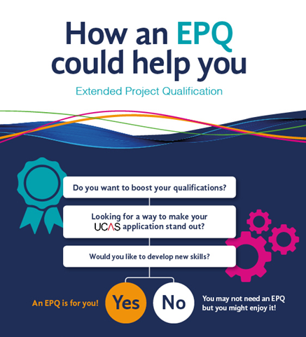
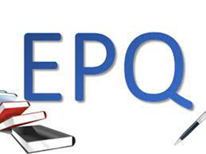

Thoughts from our Previous Students

It’s the staff that make the Joseph Whitaker Sixth Form such an amazing place to study. Teachers were incredibly passionate and spread their love of their subjects to the students. Many dedicated their own time to provide (much needed!) afterschool study support. While completing my EPQ, my tutor guided me through a minefield of research and somehow managed to make the process of writing a dissertation fun.

Teachers supported me through an application to Cambridge, a change of course and even more applications to American universities. No matter what career path or university you choose, you will be met with experienced and supportive guidance.

There is an unbelievable number of non-academic opportunities that really strengthen friendships in the student community. I loved completing my Gold Duke of Edinburgh expedition to the Lake District, skiing in Austria and travelling to Morocco on an exchange/volunteer trip. Being a “Red Shirt” is something unique to the Jo Whit experience and the opportunity to have a paid position during lunch break was so useful to build savings for uni.

I wouldn’t have wanted to study A-levels anywhere else!



Fern Millhouse
Third Year
Cambridge Undergraduate


Attending the Joseph Whitaker Sixth Form equipped me with the tools, support, and capacity to succeed. During my time there, I studied Biology, English, and Geography, and I am deeply grateful to the attentive teaching staff who made my experience so transformative, as well as to the lifelong friends that I made over those two years.

In Year 13, I was fortunate enough to receive offers to study at Cambridge, Princeton, and Harvard University, ultimately choosing to attend Harvard. My success is a testament to the quality of the Sixth Form experience at Joseph Whitaker — one which I would recommend unreservedly to any prospective student.

James Farr
Harvard Graduate
Now working in a New York investment company

Thoughts from our Previous Students

The main thing that sticks out for me during my time at the Joseph Whitaker Sixth Form was the amazing support provided by the teachers both inside and outside of the classroom. Inside the classroom, I was encouraged to dive deeper into my chosen subjects, ask questions and connect concepts together to see the bigger picture. Outside of the classroom, we were given opportunities to develop personally, share ideas and try new things.

In addition to the support that was offered day in, day out, I truly realised how special the Joseph Whitaker Sixth Form was when I started applying for university. I chose to apply to Cornell University in America, to study Mechanical Engineering and I was overwhelmed by the amount of help I received during this process. The teachers at the Sixth Form put so much time and energy into giving my application the best possible chance and I will forever be grateful for the input that they had. Telling those who had helped me that we had been successful, was an incredibly special moment and it showed without doubt how much the Sixth Form cares about its students.

I know for certain that I wouldn’t be where I am now without the support of the Sixth Form and I believe there is no place better to grow and improve, whilst having fun along the way!


Alice Jones
Final Year
Cornell Undergraduate


I came to the Joseph Whitaker Sixth Form from Samworth Church Academy because I decided it would give me the opportunity to grow in confidence and experience new opportunities, as well as giving me an excellent education. After the positive experience my sister had at the Sixth Form, it was a no brainer I would follow in her footsteps. My teachers and other students were so welcoming, from day one I was submerged in a lovely friend group, and I have made friends and memories for life. One of my favourite memories was the ski trip in year 12, something completely out of my comfort zone but I am so glad I did it.

Emily Hitchcock
Third Year
Nottingham Trent
Undergraduate

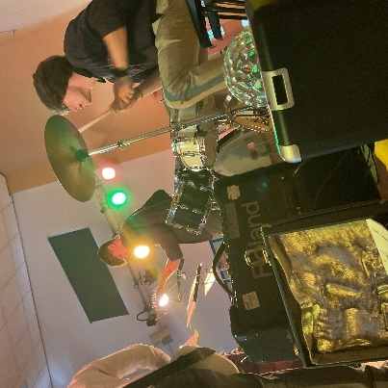
Sixth Form Life

I came from another school and settled quickly and made friends. I like it!


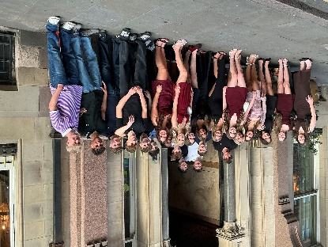



Good food!



I enjoy how subjects are a step up from GCSE and the work gets harder.

We joined in the Staff Lip Sync Battle and had a right laugh!

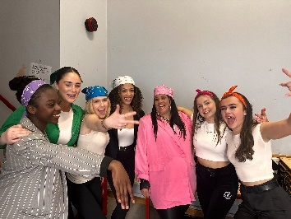
Teachers make sure the transition from GCSE content to A Level content is smooth.

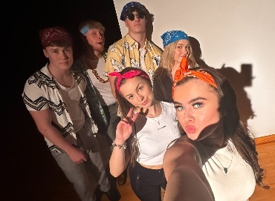

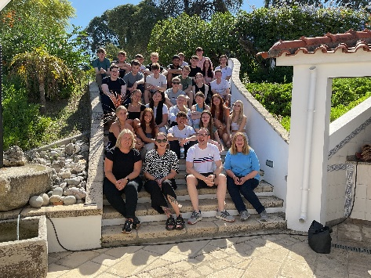
Sixth Form Life

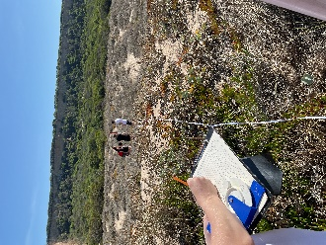

Support is always there and constantly provided.


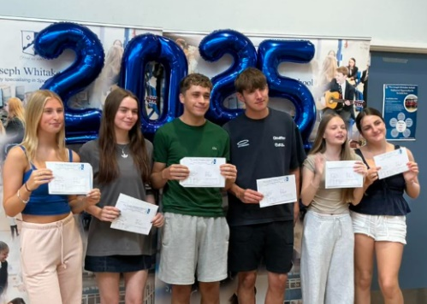

The teachers make me want to be better.
The Sixth Form ski trip has given me memories I will never forget!

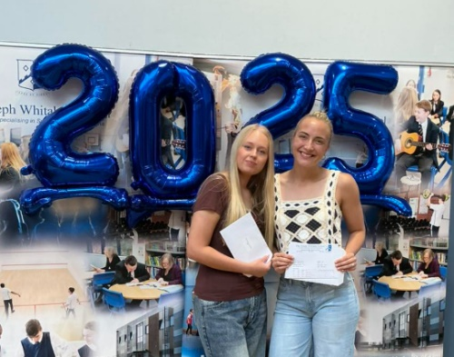



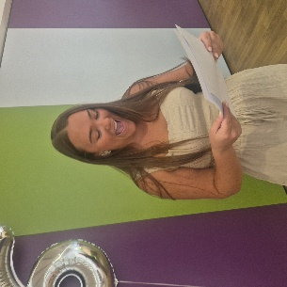

I got a job as a Red Shirt so I ‘Earn as I Learn!’
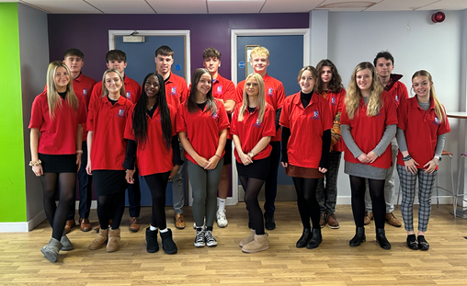

For more Information and

to Apply



Scan the QR code above to begin your application to join us
Sixth Form Open Evening is Wednesday 4th November 2026 from 5.30pm to 8.00pm
Booking is not required
Come and speak to the subject teachers about what each course has to offer
For more information, please email post16@josephwhitaker.org

